CAREER FAIR REGISTRATION
@CREATIVITY THINK (9483175986/7019689991)

ABSTRACT:
Career Fair Registration is a web-based application designed to facilitate seamless registration and management of career fairs and recruitment events for colleges, placement cells, and job agencies. The system allows users to register, upload resumes, schedule interview slots, and track participation status through an interactive dashboard. Administrators can manage companies, events, resumes, and monitor analytics on participation and downloads. Built using Django and Django Rest Framework for backend operations and React with redux and pdfkit for frontend management, the platform provides a secure, efficient, and structured environment for organizing career fairs digitally..

INTRODUCTION OF THE PROJECT:
Traditional career fairs often rely on manual registrations, spreadsheets, and paper-based resume submissions, leading to inefficiencies and difficulty in tracking attendees and interview schedules. Career Fair Registration addresses these challenges by providing a centralized, digital platform for event registration, resume uploads, scheduling, and analytics tracking. Users can efficiently register, manage schedules, and monitor their application status, while administrators can oversee company participation, download resumes, and analyze overall engagement, improving event management efficiency..

PROJECT OBJECTIVES:

• Enable users to register for career fair events
• Allow resume uploads and management
• Facilitate scheduling of interview slots
• Provide real-time tracking of application and attendance status
• Enable administrators to manage companies, events, and participants
• Generate dashboard analytics for event performance and engagement
• Track resume downloads and participation metrics
• Ensure secure data storage and user privacy

PROBLEM OF THE STATEMENT:
Manual management of career fairs often leads to registration errors, missed schedules, untracked resume submissions, and lack of actionable analytics. Administrators struggle to monitor company participation, resume downloads, and event effectiveness. Career Fair Registration solves these challenges by providing a centralized, secure, and automated platform that streamlines registration, resume management, scheduling, and analytics reporting..

MOTIVATION OF THE PROJECT:
• To digitize career fair registration and attendance tracking
• To simplify resume submission and management
• To automate interview slot scheduling
• To provide users with a transparent dashboard for participation tracking
• To allow administrators to monitor companies, resumes, and events efficiently
• To generate data-driven insights through dashboard analytics
• To enhance engagement and reduce manual administrative effort

BLOCK DAIGRAM OF PROJECT:

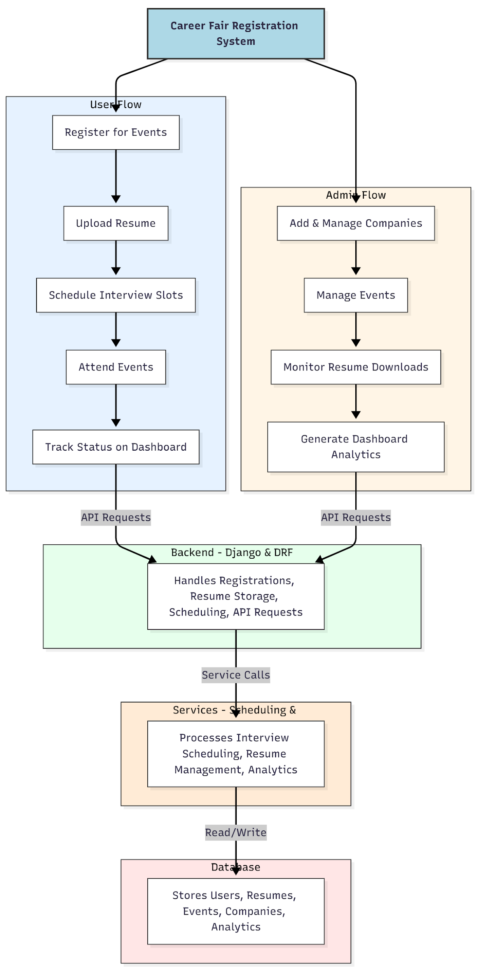

WORKING OF THE PROJECT:
Users register for career fair events and upload their resumes through the frontend interface. The backend validates registrations, stores resumes securely, and schedules interview slots. Users can view their upcoming events and track attendance and application status via a dashboard. Administrators manage companies and events, monitor resume downloads, and oversee analytics on user participation. All interactions are logged, and the services module handles scheduling, analytics processing, and data integrity, while the database stores all structured information, ensuring a smooth, secure, and traceable workflow..

SOFTWARE REQUIREMENT:
- Backend:
  - Python 3.x
  - Django
  - Django REST Framework
  - SQLite/PostgreSQL
- Frontend:
  - Node.js and npm
  - React.js
  - Axios
- Development Tools:
  - Visual Studio Code
  - Postman (for testing APIs)
  - Git/GitHub (for version control)
- Server/Deployment (Optional):
  - Gunicorn, Nginx, or Heroku/AWS for hosting

ADVANTAGES OF THE PROJECT:

• Streamlined event registration and resume submission
• Automated scheduling of interview slots
• Dashboard analytics for users and administrators
• Transparent tracking of resume downloads and participation
• Reduces administrative workload and manual errors
• Provides secure data storage and access control
• Enhances overall event management efficiency
• Scalable for colleges, placement cells, and job agencies

APPLICATIONS OF THE PROJECT:
• Colleges and universities
• Placement cells
• Job agencies and recruitment firms
• Career expos and recruitment drives
• Internship and training program events

REFERENCES:

- Django REST Framework Documentation — Django Software Foundation. Django Documentation. Available: https://docs.djangoproject.com/
- Django REST Framework. DRF Documentation. Available: https://www.django-rest-framework.org/
- React. React Official Documentation. Available: https://reactjs.org/docs/getting-started.html
- Redux. Redux Documentation. Available: https://redux.js.org/introduction/getting-started
- PostgreSQL Global Development Group. PostgreSQL Documentation. Available: https://www.postgresql.org/docs/
- MySQL. MySQL Reference Manual. Available: https://dev.mysql.com/doc/
- Git. Git Documentation. Available: https://git-scm.com/doc
- Node.js. Node.js Documentation. Available: https://nodejs.org/en/docs/
- Axios. Axios Documentation. Available: https://axios-http.com/docs/intro
- Socket.io Documentation – https://socket.io/docs/

